**Experiment No :** 10

**Experiment name** Write a C program to find GCD of two numbers using recursion.

**Methodology :**

To find the Greatest Common Divisor (GCD) of two numbers using recursion in C, you can use the Euclidean algorithm. The Euclidean algorithm states that the GCD of two numbers is the same as the GCD of the smaller number and the remainder of the division of the larger number by the smaller number. The process is repeated recursively until one of the numbers becomes zero, and the other number will be the GCD..

**Flow-Chart :**

int num1 , num2 ;

S**Code :**

False

True

return num1;

return rcf(num2 , num1 % num2);

If

num2 != 0

Display : num1 , num2

scanf("%d %d",&num1 , &num2);

While

Num1 !=num2

#include<stdio.h>

int recf(int num1 , int num2 )

int rcf(int num1 , int num2 ){

if(num2 != 0 ){

return rcf(num2 , num1 % num2);

}

else{

return num1;

}

}

int main(){

int num1 , num2 ;

printf("Enter two number : ");

scanf("%d %d",&num1 , &num2);

printf("G.C.D of %d and %d is %d",num1 , num2 , rcf(num1,num2));

return 0;

}

**Output:**

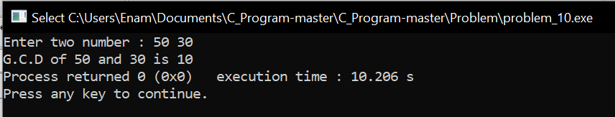

**Result discussion :**

1. he gcd_recursive function is a recursive function that calculates the GCD of two numbers a and b.
2. The base case of the recursion is when b becomes zero. In this case, the GCD is a.
3. If b is not zero, the function calls itself recursively with b and the remainder of the division of a by b.
4. In the main function, the user is prompted to enter two numbers.
5. The gcd_recursive function is called with the two input numbers to calculate their GCD.
6. The program then prints the GCD of the two input numbers.